Strong Induction, Zaiwei Recommended Question:
Let an be the sequence defined by a₁ = 1, a₂ = 8, and a_{n} = a_{n−1} + 2a_{n−2} for n ≥ 3.
Prove that a_{n} = 3 * 2^{n−1} + 2(−1)^{n} for all n ∈ N.

Base Cases:
- a₀ = 3/2 + 2 = 5/2
- a₁ = 1, so 1 = 3 * 2^{(1 – 1)} + 2*(-1)^{n} = 1
- a₂ = 8, so 8 = 3 * 2¹ + 2(-1)² = 8
Therefore, both base cases have been proven.

Inductive Case:
Assume P(k) is True, try and prove for P(k + 1).
- P(k + 1) = a_{k-1} + 2a_{k-2} = 3*2^{k-1} + 2*(-1)^{k} + 2(3*2^{k-2} + 2*(-1)^{k-1})
= 3*2^{k-1} + 2*(-1)^{k} + 6*2^{k} * 1/4 – 4*(-1)^{k} = 3*2^{k} / 2 + 3*2^{k} / 2 – 2*(-1)^{k}
= 3*2^{k} – 2*(-1)^{k+1} = 3*2^{k} + 2(-1)^{k+1}
  - We have proven P(k + 1) where n = k + 1

By proving base cases, P(k), and P(k + 1), this theorem is True.

Big O, Zaiwei Recommended Question:
Use the definition of O(g(x)) to show that f(x) = (x³ + x² + x) / (2x + 10) is O(x²).
Be sure to indicate the values you used for the witnesses.

Determine an easier function by disregarding constant of 10:
- f₁(x) = (x³ + x² + x) / (2x + 10) and f₂(x) = (x³ + x² + x) / 2x where f₂(x) > f₁(x)
- Simplify f₂(x) = x² / 2 + x / 2 + 1 / 2
  - Therefore, f₂(x) = x² / 2 + x / 2 + 1 / 2 <= x² + x² + x²= 3x² , thus C = 3

k = 1, which is a point where 3x² is greater than x² / 2 + x / 2 + 1 / 2:
- x² / 2 <= x², x <= x², and 1 / 2 <= x² when x > 1

Determine Answer:
- |x² / 2 + x / 2 + 1 / 2| <= |3x^{2|}| for C = 3 and x > 1
- |3x^{2|}| >= |x² / 2 + x / 2 + 1 / 2| >= |(x³ + x² + x) / (2x + 10)|

Therefore, by definition of Big O, f(x) is O(x^2).

Definitions, Recommended by Zaiwei
1. What is a bipartite graph? (Give an example)
Bipartite Graph: A graph whose vertices can be divided into two independent sets, U and V, such that every edge (u, v) either connects a vertex from U to V or a vertex from V to U.
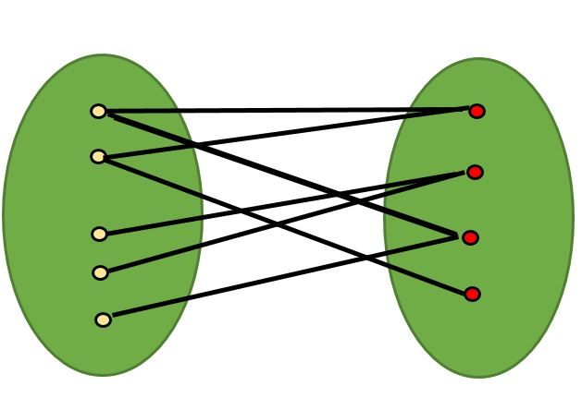

Complete Bipartite Graph: There is an edge from every vertex in U to every vertex in V.
2. What is a Euler circuit, Euler path? (Give an example)
- Euler Circuit: A circuit that uses every edge of a Graph exactly once, cannot re-use edges.
- Euler Path: A path that uses every edge of a Graph exactly once, cannot re-use edges.
3. What is a Hamilton circuit, Hamilton path? (Give an example)
- Hamilton Circuit: A circuit that uses every vertex of a Graph exactly once, cannot re-use vertices.
- Hamilton Path: A path that uses every vertex of a Graph exactly once, cannot re-use vertices.
4. What is a connected component?
- Connected: An undirected graph is connected if there is a path between every pair of distinct vertices of the graph. There cannot be any openings within the graph. (K1, K2, K3… etc)

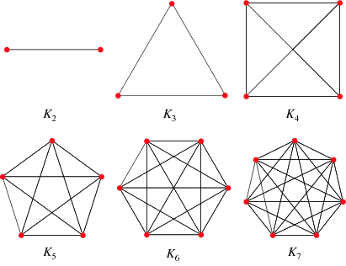

- Connected Component: A connected sub-graph of G that is NOT a proper sub-graph of another connected sub-graph of G
5. What are cut vertices and cut edges of a graph?
- Cut Vertex: If removing it and incident edges, produces a sub-graph of connected components
- Cut Edge: If removing it, produces a sub-graph of connected components
6. What is line (edge) connectivity and what is vertex connectivity?
- Edge Connectivity λ(G): Minimum number of edges to remove for a disconnected graph
- Vertex Connectivity κ(G): Minimum number of vertices to remove for a disconnected graph

